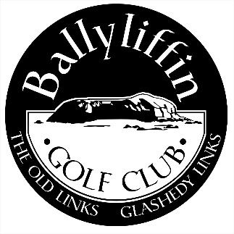
Application for Young Adult Membership 2022

NAME

ADDRESS

TEL.NO.(HOME) …………………… (MOBILE) ………………………………...

(BUSINESS) …………………............. (EMAIL) ……………………………........

D.O.B. ………………………….. CATEGORY: YOUNG ADULT
(Photo ID Required)

METHOD OF PAYMENT Cheque Visa/Mastercard Cash

Credit Card No. ___________________________ Exp. Date ____________________

PROPOSED BY _____________________________Membership No. _________

SECONDED BY _____________________________Membership No._________

Signature ___________________________________ Date ____________________

Ballyliffin Golf Club, Ballyliffin, Inishowen, Co. Donegal, Ireland
Tel: 074 93 76119 *International Calls: 0035374 * info@ballyliffingolfclub.com * www.ballyliffingolfclub.com

Applications must be Proposed & Seconded by a Full Adult Member or Lady Associate Member of 5 years standing.

Young Adult Membership Rules 2022

YOUNG ADULT MEMBERSHIP – Persons over 18 years and under 30 on January 1st of the Subscription year. Proof of age must be submitted.
An entrance fee of €500 applies to Young Adult Membership.
Young Adult Members are eligible to compete for Captain’s and President’s Prizes and to attend and vote at General Meetings of the Club.
Young Adult Members will be entitled to a member’s discount card and may hold a handicap.

Entrance fees and conditions for membership are subject to review by the council of Ballyliffin Golf Club and should be confirmed at time of application.

Local & Non Local Young Adult Membership

One Off Entry Fee €500
Subscription €525.00 TBC
Golf Ireland €24
Insurance €25
Members Swipe (Optional) €50

Members Swipe €50
€1124.00

